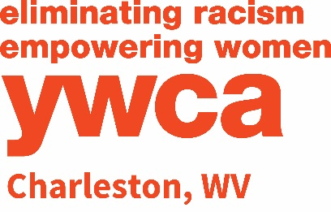
Volunteer Application Form
Instructions: Complete form. Save to your computer, then email as an attachment to athaxton@ywcacharleston.org. Please type “Volunteer Application” in the subject line of your email.
Name:
Address:
City, State Zip:
Preferred Phone Number:
Email Address:
Optional Information:
Employer: Position Held:
Work Phone Number: Work Email Address:
YWCA Charleston is committed to the health and safety of our program participants thus if you intend on being a regular volunteer (six or more times a year) you will be required to complete a background screen at the cost of $20.
YWCA Charleston will consider underwriting the entire cost of the background screen if you are unable to pay.
Do you intend on being a regular volunteer? Yes No

As an insurance requirement, YWCA Charleston must complete a Motor Vehicle Report (MVR) to obtain your driving record if you will be using a YWCA vehicle as part of your volunteer experience.

To obtain the form necessary for the YWCA to obtain your Motor Vehicle Report, please check this box
Prior approval is needed from the Volunteer Coordinator at each site before children are permitted to volunteer.
Supervisors must arrive and remain with the child(ren) who are volunteering at all times.
AREAS OF INTEREST: (Check all that apply)
YWCA Sojourner’s Shelter for Homeless Women and Families
Contact: Ronni Spudich, Assistant Program Director at (304) 340-3562
- Assisting facilities personnel with minor repairs
- Clerical work (experience with Excel, data entry, forms, etc., is preferable)
- Volunteer to pick up food and donations and move residents (requires light lifting). Provide own truck.
- Cooking healthy meals for residents
- Assist with prep and/or cooking of special dinners
- Various projects working with children.
- Committee work with fundraising events such as the annual Guy’s Night Out, Foodie Feast and Style Show, all benefiting the YWCA Sojourner’s Shelter for Homeless Women and Families
- Other:
YWCA Resolve Family Abuse Program
Contact: Julie Haden, Program Director at 304-340-3354
- Volunteers to become involved with the Children's Mentoring Program for Children's Group and Teen Group on Tuesdays at 5 p.m.
- Landscaping, weeding, mulching in the spring through fall.
- Committee work with Girl’s Night Out fundraiser
- Various projects with residents or children such as artwork, painting, etc
- Other:
YWCA Shanklin Center for Senior Enrichment, Alicia McCormick Homes and Empowerment Homes for Women
Contact: Kyla Nichols, Program Director at (304) 415-2682
- One-on-one visitations with YWCA Shanklin residents
- Landscaping (weeding, mulching, etc.) in the spring through fall
- Other:
YWCA Mel Wolf Child Development Center
(must be 18 years or older to volunteer)
Contact: Jenna Elmore, Program Director at (304) 340-3560
- Tutoring with after school program
- Reading aloud
- Mowing, landscaping (weeding, mulching, etc.) in the spring through fall
- Sharing your time and interests with children from 6 weeks - 12 years in age
- Other:
YWCA Past & Present Gently Used Clothing Store
Contact: Erin Turner, Manager of Retail Operations at (304) 340-3646
- Sorting donations, pricing, and/or clerking
YWCA Management and General
Contact: Kate Flack, Communication & Development Director at (304) 340-3594
- Fund Raising
- Communications
- Other Administrative Duties (Please specify) _____________________________________________
Other: (Please specify) _________________________________________________________________

